Stock Market Risk Analysis
Assessing a company's financial risk goes beyond simply analyzing stock price movements. Although a stock represents an ownership stake in a company, its price fluctuations are driven by market sentiment, investor behavior, and macroeconomic factors that do not necessarily reflect the firm's underlying financial health. To bridge this gap, specialized methodologies have been developed to evaluate corporate solvency and default risk more rigorously. Among the most widely recognized are the Altman Z-Score, which uses accounting-based ratios to predict financial distress, and the Merton Default Probability model, which applies option pricing theory to estimate the likelihood of a firm defaulting on its obligations.
Models:
The Altman Z-Score is a quantitative model developed in 1968 by Edward Altman to predict the likelihood that a company will experience financial distress within two years. Using Multiple Discriminant Analysis, the model combines five weighted financial ratios covering liquidity, cumulative profitability, operating efficiency, financial leverage, and asset utilization into a single composite score that classifies firms as financially sound, distressed, or in a gray zone of uncertainty. Originally designed for publicly traded manufacturing companies, Altman formula was:
$$Z=1.2X_{1}+1.4X_{2}+3.3X_{3}+0.6X_{4}+1.0X_{5}$$
Where:
$X_{1}=\frac{Working Capital}{Total Assets}→$ Liquidity Ratio
$X_{2}=\frac{Retained Earnings}{Total Assets}→$Cumulative Profitability Ratio
$X_{3}=\frac{EBIT}{Total Assets}→$Operating Efficiency Ratio
$X_{4}=\frac{Book Value of Equity}{Total Liabilities}→$Leverage Ratio
$X_{5}=\frac{Sales}{Total Assets}→$Asset Turnover Ratio
The model was later adapted into two additional variants:
The Z'-Score for private firms:
$$Z'=0.717X_{1}+0.847X_{2}+3.107X_{3}+0.420X_{4}+0.998X_{5}$$
And the Z''-Score for non-manufacturing and emerging market entities:
$$Z''=6.56X_{1}+3.26X_{2}+6.72X_{3}+1.05X_{4}$$
The Merton model, introduced by Robert Merton in his 1974 paper "On the Pricing of Corporate Debt," is a structural credit risk model that estimates the probability of a firm defaulting on its obligations by treating a company's equity as a call option on its underlying assets. The core logic is straightforward: at the maturity of the firm's debt, shareholders receive the difference between asset value and liabilities if assets exceed debt, or nothing at all if liabilities exceed assets. A payoff structure identical to that of a call option, expressed as $E_{T}=max⁡(A_{T}-L,0)$. Using the Black-Scholes-Merton framework and assuming asset returns follow a lognormal distribution, the model relates the observable market value of equity to the unobservable market value of assets, then computes a key metric called the Distance to Default (DD):
$$DD=\frac{\ln\left(\frac{A}{L}\right)+\left(μ_{A}+\frac{1}{2}σ_{A}^{2}\right)T}{σ_{A}\sqrt{T}}$$
Where:
A = Total Assets
L = Total Liabilities
$μ_{A}$ = Expected Return of the Assets (Drift Parameter)
$σ_{A}$ = Volatility of the Company’s Assets
T = Time Horizon
The number of standard deviations separating the firm's expected asset value from the liability threshold at maturity. The probability of default is then derived as:
$$PD=1-N(DD)$$
Where a lower distance to default implies a higher likelihood of insolvency. Unlike the Altman Z-Score, which relies on historical accounting ratios, the Merton model is forward-looking and market-driven, incorporating both the current market value of assets and their volatility to produce a dynamic, continuous measure of credit risk.
Implementation:
The Altman Z-Score was implemented as a Python class that computes each of the five component ratios from a company's financial statements, retrieved automatically using the ticker symbol. The five ratios are each encapsulated in dedicated methods to ensure modularity and clarity. Following Altman's original specification, the first four ratios are scaled as absolute percentage values before being multiplied by their respective coefficients, while the asset turnover ratio is kept as a decimal. The final Z-Score is then computed as $Z=1.2X_{1}+1.4X_{2}+3.3X_{3}+0.6X_{4}+0.999X_{5}$, consistent with Altman's original 1968 formulation.
The Merton model was implemented as a separate class that derives default risk from the firm's asset dynamics rather than accounting ratios. The liability threshold, serving as the default point, is calculated as current liabilities plus 50% of long-term debt, a standard approximation used in practice to reflect that short-term obligations represent a more immediate default trigger than long-term ones. Asset volatility and expected asset return are both estimated from the historical time series of total assets, using annualized log returns under the lognormal distribution assumption. The Distance to Default is then computed using the formula $DD=\frac{\ln\left(\frac{A}{L}\right)+\left(μ_{A}+\frac{1}{2}σ_{A}^{2}\right)T}{σ_{A}\sqrt{T}}$. Finally, the probability of default is derived as $PD=1-N(DD)$, where N is the cumulative standard normal distribution, translating the distance to default into an explicit probability of insolvency.
Using both models a credit decision is made. The credit decision logic combines the outputs of both models into a unified approval framework implemented in the CreditDecision class. Once the Altman Z-Score and Merton Probability of Default are computed for a given company, they are evaluated jointly against four thresholds: a Z-Score of 3.0 as the safe zone boundary, 1.8 as the distress zone boundary, a 5% PD as the low-risk ceiling, and 15% as the high-risk floor. The 5% threshold corresponds to the upper limit of investment-grade credit quality, where historically observed one-year default rates remain well below this level. The 15% threshold marks the entry into distressed credit territory, consistent with the empirically observed default rates of CCC-rated firms as documented by major rating agencies such as S&P and Moody's.
A credit application is approved when both models signal financial soundness, Z-Score at or above 3.0 and PD at or below 5%, or when one model indicates safety while the other falls in the gray zone, reflecting that a strong signal from one framework is sufficient to offset ambiguity in the other. A denial is issued when either model places the firm in its respective distress zone, Z-Score below 1.8 or PD at or above 15%, regardless of what the other model indicates, as a single clear warning signal is treated as disqualifying. The only remaining case that also results in denial is when both models simultaneously fall in their gray zones, since the absence of any positive confirmation from either perspective is treated as insufficient grounds for approval. This dual-model structure is deliberate — the Altman Z-Score captures the firm's historical financial health through balance sheet and income statement ratios, while the Merton model provides a forward-looking, market-driven estimate of default risk, and requiring both to align before granting approval reduces the likelihood of approving a company that appears healthy on paper but carries elevated structural default risk, or vice versa.
The results are presented through an interactive Streamlit dashboard that consolidates the analysis into three sections: the Altman Z-Score results, the Merton default probabilities, and a combined view where both models are evaluated together to produce a final credit decision. A summary table displays each analyzed company alongside its Z-Score, probability of default, and approval status, complemented by aggregate metrics showing the total number of approved and denied firms as well as the overall approval rate across the entire analyzed portfolio.
Results
This credit decision approval was performed on 6 different companies:
- American Tower Corporation (AMT)
- Broadcom Inc. (AVGO)
- Eli Lilly and Company (LLY)
- Taiwan Semiconductor Manufacturing Company Limited
- Visa Inc. (V)
- Walmart Inc. (WMT)
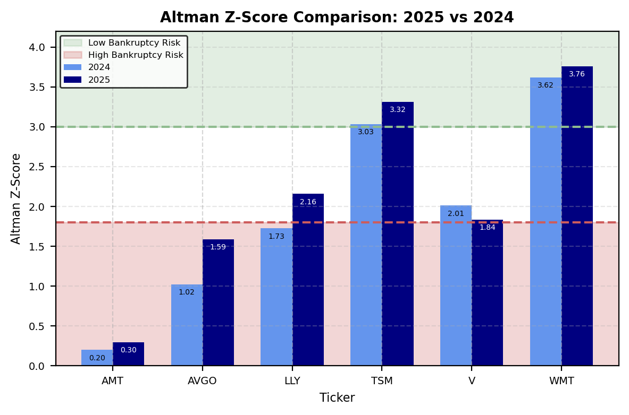
The Z-Score results reveal a clearly polarized picture across the six analyzed companies. AMT stands as the most concerning case, with scores of 0.20 and 0.30 in 2024 and 2025 respectively, placing it deep within the high bankruptcy risk zone and showing virtually no improvement year over year. AVGO similarly remains in distress territory despite a notable improvement from 1.02 to 1.59, while LLY moves from distress into the gray zone with a 2025 score of 2.16, suggesting a positive trend but still insufficient to confirm financial soundness. V presents an interesting case, deteriorating from a gray zone score of 2.01 in 2024 to 1.84 in 2025, narrowly above the 1.8 distress threshold. In contrast, TSM and WMT are the standout performers, with both firms comfortably situated in the low bankruptcy risk zone in both years and showing further improvement in 2025, reaching scores of 3.32 and 3.76 respectively, the only two companies in the sample that would meet the Z-Score approval threshold of 3.0 defined in the credit decision framework.
The dashboard also presents an individual ratio breakdown for each company through a set of spider charts, one per ticker, each displaying the five Altman Z-Score components (profitability, liquidity, leverage, turnover, and efficiency) along their respective axes. The radar format allows for an intuitive visual comparison of a firm's financial profile across all five dimensions simultaneously, making it easy to identify which specific ratios are driving strength or weakness in the overall score. Each chart overlays two polygons representing the 2024 and 2025 fiscal years, enabling a year-over-year comparison of how each ratio has evolved individually, rather than only observing the aggregate score. This granular view complements the bar chart by revealing the underlying composition of each company's Z-Score, providing a more complete diagnostic picture of where each firm stands across the different dimensions of financial health.
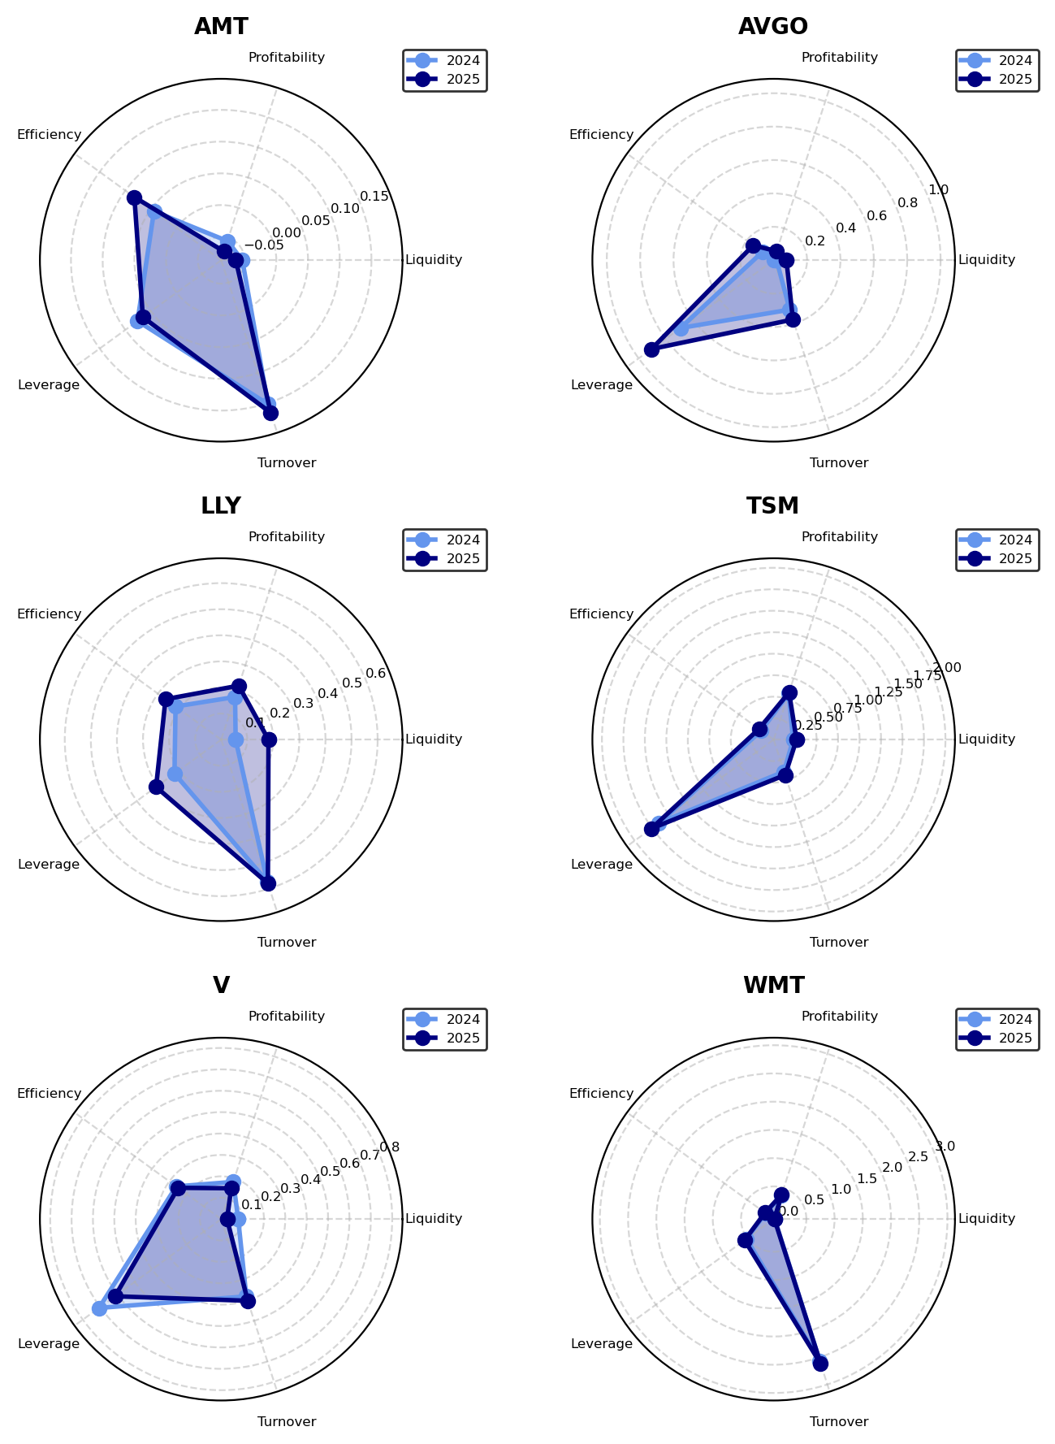
The Merton model results present a notably different picture from the Altman Z-Score analysis. Five of the six companies (AMT, LLY, TSM, V, and WMT) register a probability of default of 0.00%, indicating that based on the asset value dynamics and volatility observed in their historical financial data, the model finds no meaningful probability of their asset value falling below the liability threshold within the defined time horizon. AVGO is the sole exception, with a PD of 5.20%, placing it precisely at the boundary of the low-risk threshold defined in the credit decision framework. This result is particularly noteworthy given that AVGO also showed a low Z-Score of 1.59 in the Altman analysis, suggesting that while its accounting-based profile signals financial stress, the market-based structural model considers an actual default event to be only marginally probable. The near-zero PDs across most of the sample reflect the model's sensitivity to asset volatility. Companies with relatively stable asset bases over time will produce low distance-to-default values and consequently very low default probabilities, which highlights an important limitation of applying the Merton model to annual financial statement data rather than higher-frequency market data.
The combined credit decision output is presented through two complementary visualizations. The first is a scatter plot that maps each company along two axes (the Altman Z-Score on the horizontal axis and the Merton probability of default on the vertical axis) with the four threshold boundaries drawn as dashed lines that divide the space into a denial zone (shaded in red) and an approval zone (shaded in green), allowing the viewer to immediately assess each firm's position relative to both decision boundaries simultaneously. Each company is plotted as either a green circle for approved or a red cross for denied, making the credit outcome visually intuitive within the context of the two-model framework. The second component is a summary table listing each ticker alongside its Z-Score, default probability, and final decision, accompanied by three aggregate metrics at the bottom total approved, total denied, and the overall approval rate, providing a concise portfolio-level summary of the analysis.
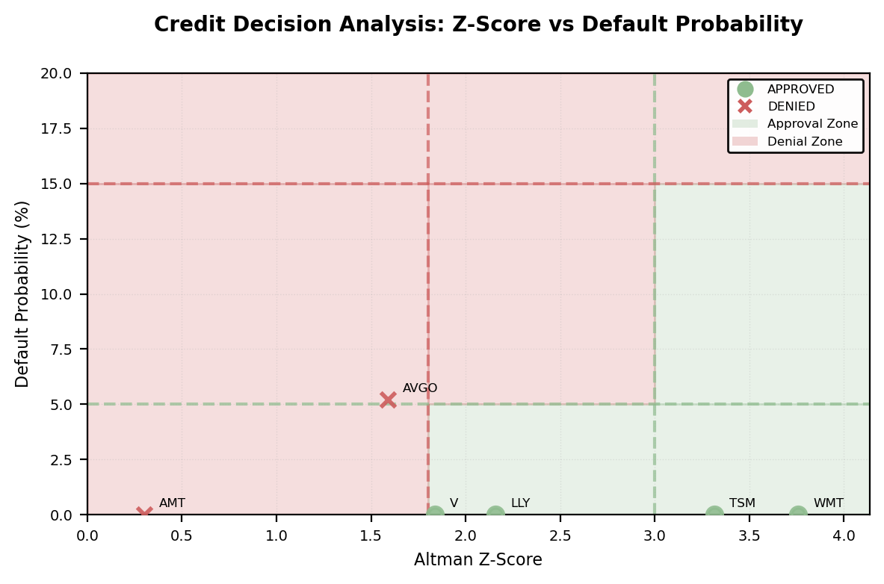
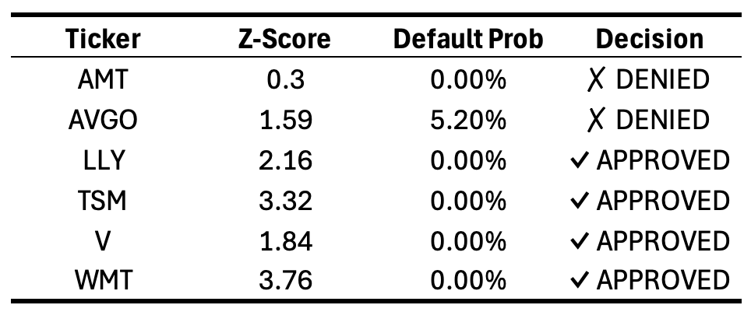
The combined credit decision analysis yields an approval rate of 66.7%, with four companies approved and two denied out of the six analyzed. AMT is denied based on its Z-Score alone, which at 0.30 places it firmly in the distress zone despite a 0.00% Merton PD, a clear case where the accounting-based model overrides the structural model's silence. AVGO is denied due to its Z-Score of 1.59 falling below the 1.8 distress threshold combined with a PD of 5.20% sitting at the boundary of the low-risk ceiling, making it the only company flagged by both models simultaneously. The four approved companies LLY, TSM, V, and WMT all register a 0.00% probability of default, and while their Z-Scores vary considerably, none fall into the outright distress zone, allowing the Merton model's clean signal to support approval in each case. Notably, V's approval with a Z-Score of only 1.84 illustrates the framework's gray zone logic in practice: a score just above the distress threshold combined with a negligible PD is sufficient for approval, reflecting the decision rule that a strong signal from one model can offset ambiguity in the other.
Sources
- Slay, R. (2023). Altman Z-Score Presentation [PowerPoint slides]. ITESO - Universidad Jesuita de Guadalajara.
- Slay, R. (2023). Merton model KMV: An introductory overview of the Merton model [PowerPoint slides]. ITESO - Universidad Jesuita de Guadalajara.
- Yahoo Finance. (n.d.). Stock market data and financial information. Retrieved February 19, 2026, from https://finance.yahoo.com/

